Insert Data Multi Language

1) Install some necessary packages 1

2) How to enable the langue param on the url 2

3) How to turn on filed translate in content 3

4) Create view Json 4

5) Create custom plugin 7

6) How to create a module to handle creating and updating multi language 10

# 1) Install some necessary packages

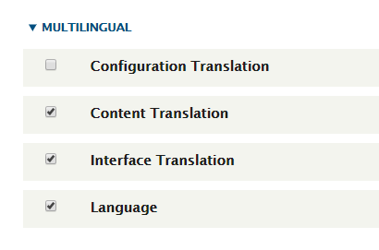

* Enable multi language module for the system

# 2) How to enable the langue param on the url

* Set url by language

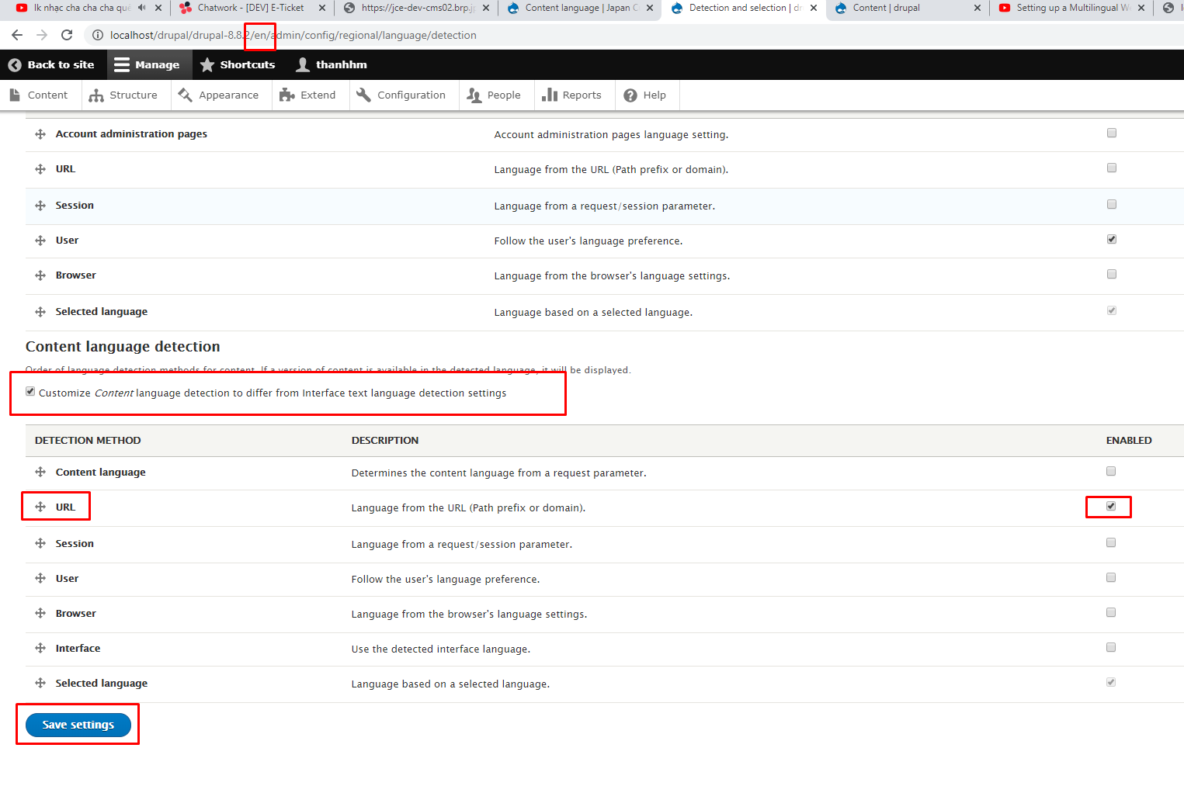

* Enable path language
* Note: Remember to delete the cache to apply the newly changed (run cmd: vendor/bin/drush cache-rebuild)
* Done, url successfully enabled.

# 3) How to turn on filed translate in content

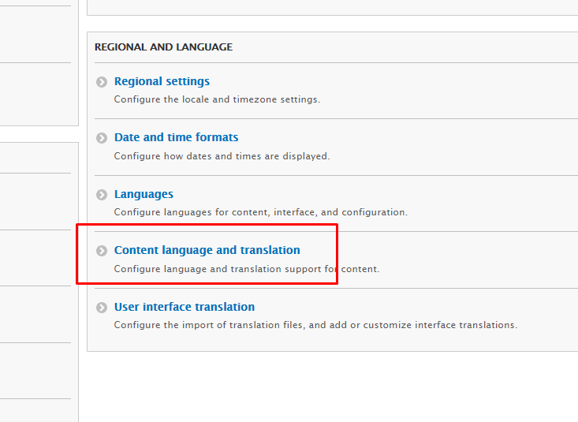

* Config

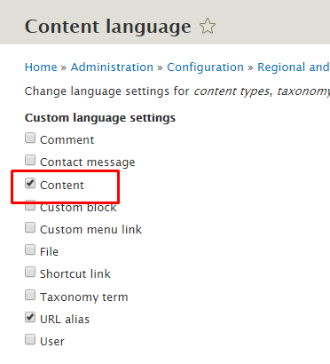

* Click checkbox content

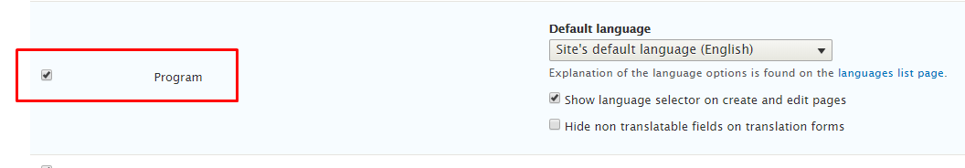

* Choose content type ‘Program’ and save

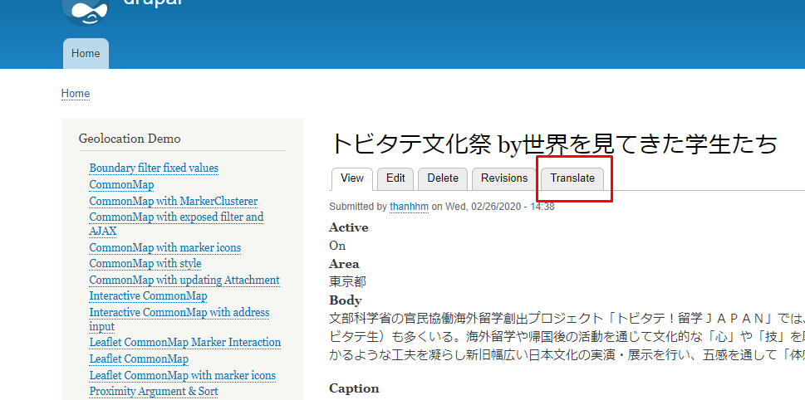

* Successful
* Note: In case language is not selected then data insert will be taken by default.

# 4) Create view Json

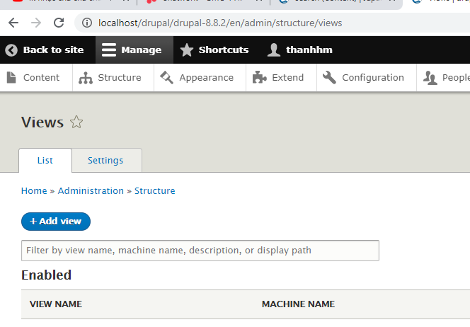

* Create search views like customers

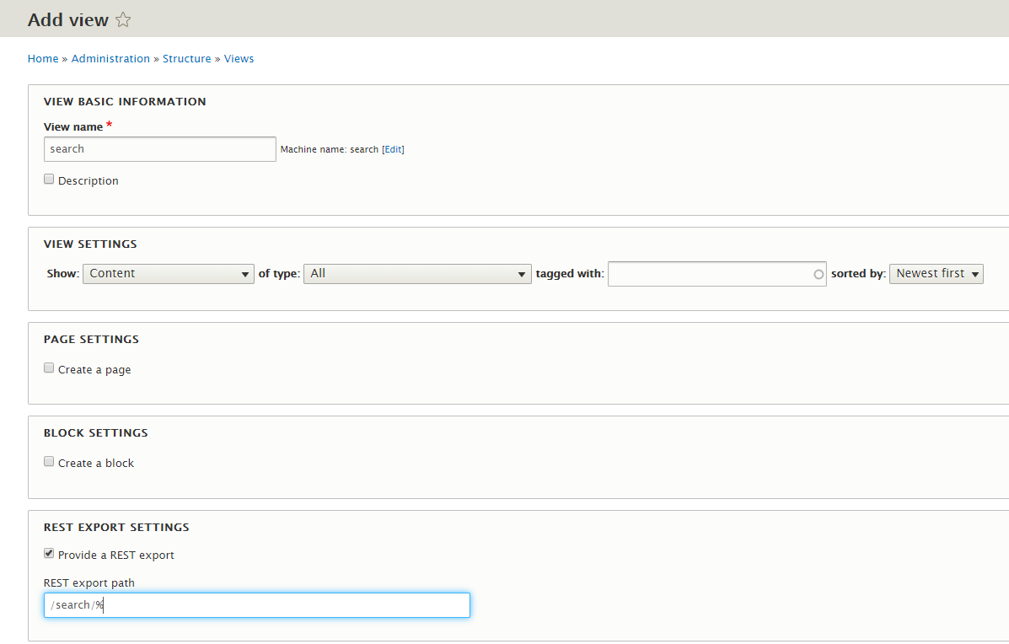

* Fill the view information

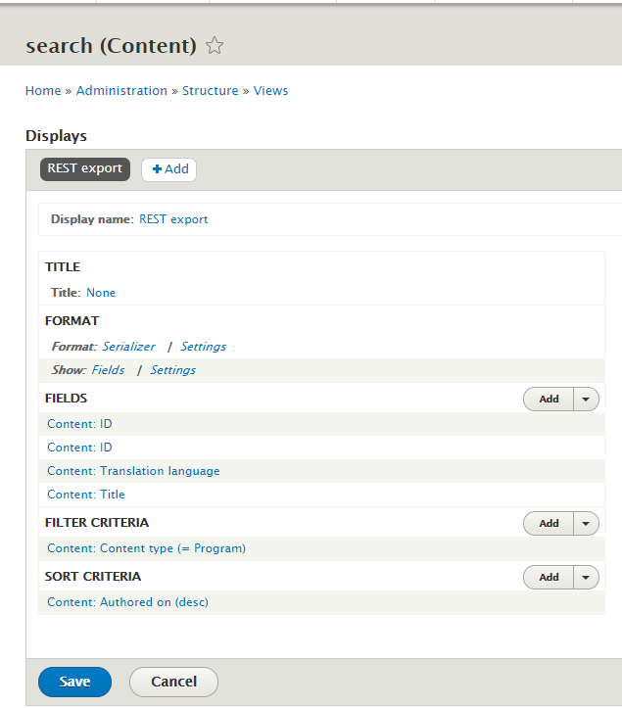

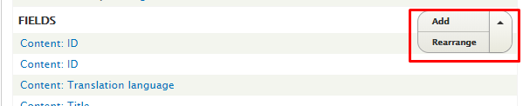

* Create fields, format as samples, re-arrange if necessary

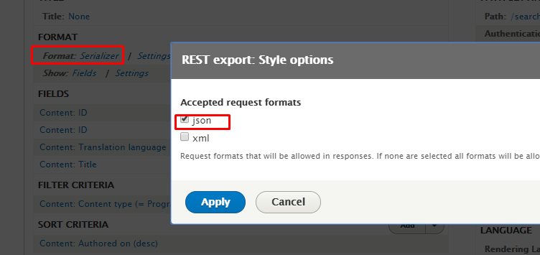

* Choose type Json

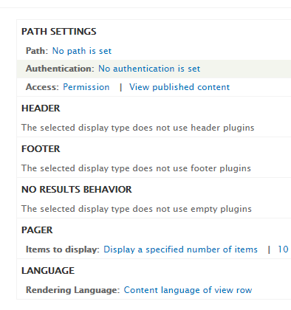

+ Set path: /search/%

+ Items display: All

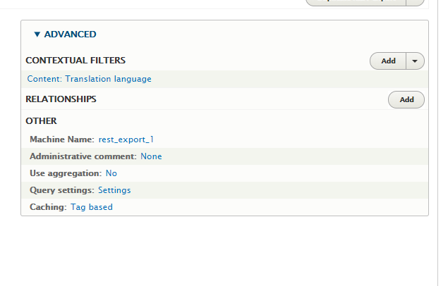

* Config Advanced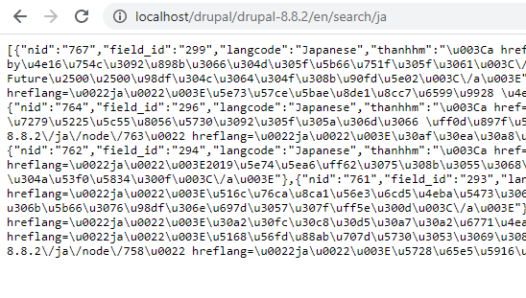
* Success

# 5) Create custom plugin

vendor/bin/drupal generate:plugin:rest:resource

* Create plugin



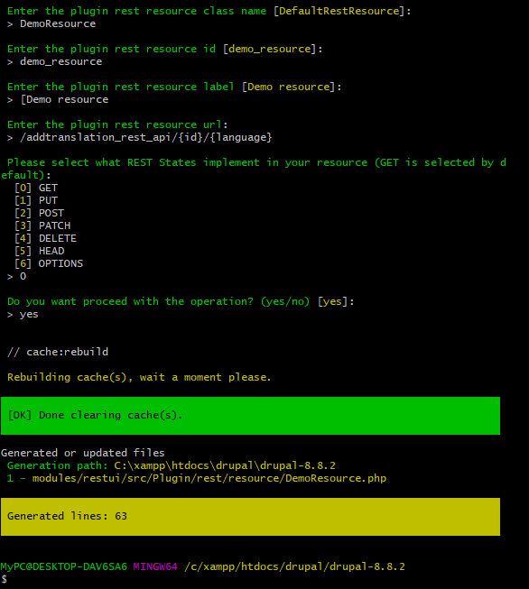



* Create plugin successful

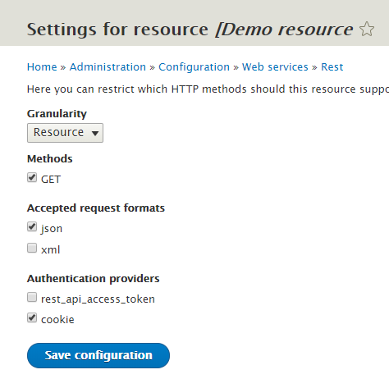

* Enable resource

After running translation.php, there are 3 cases:

+ Firstly, if the updated node already has the [EN] and [JA] versions, when the update (chient-> patch) will update into the language that we want is [EN], the [JA] version will still retain the original data.

+ Secondly, if the update node only has [JA] version, then update (Chient-> patch) will update to the existing record as [JA] => wrong language

+ Third, add the lines $fields['langcode'] = [['value' => 'en']]; Run translation.php, it will update correctly on the [EN] version, but the [JA]version will disappear.

* So we will create a module to handle these cases

# 6) How to create a module to handle creating and updating multi language

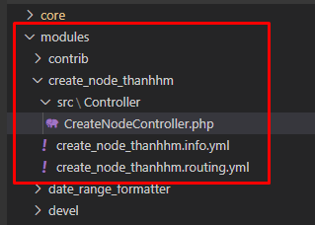

* Create directory structure

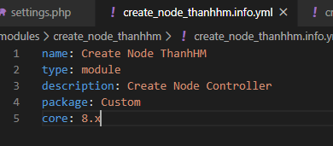

* Create a module and enable it

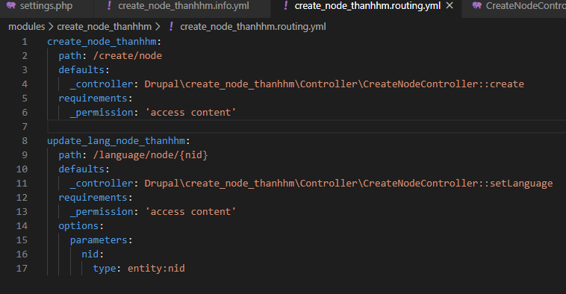

* Create a router that leads to the controller

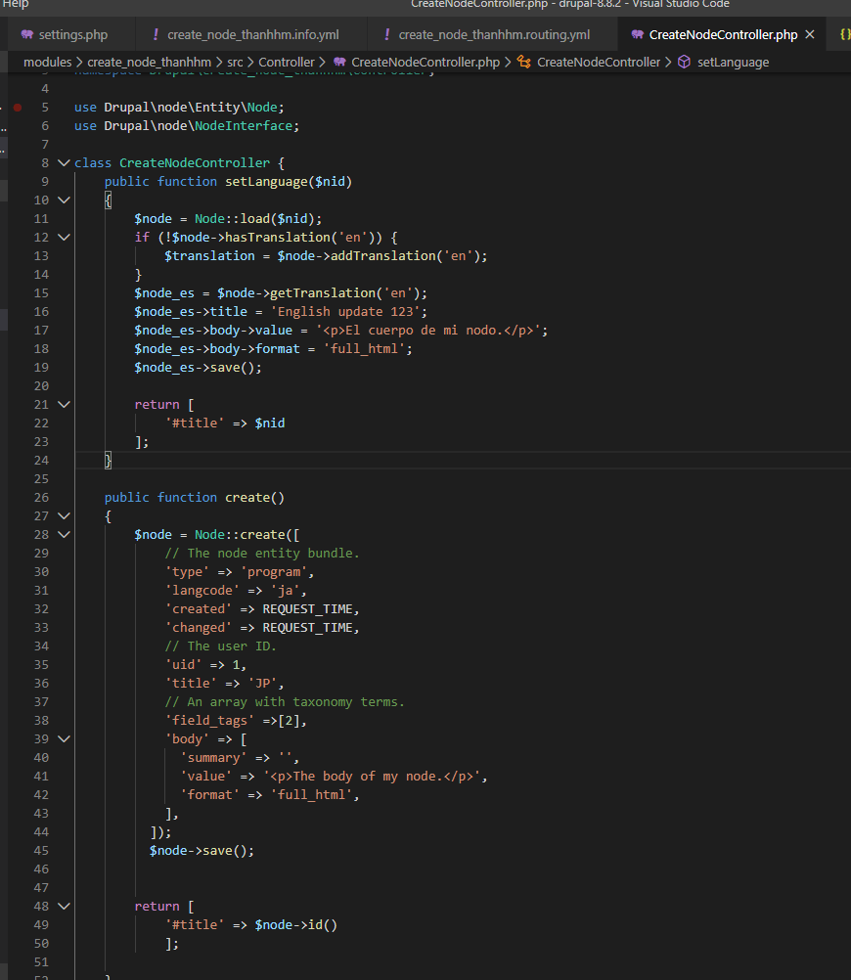

* Function create will create a note (your-domain/create/node)
* Function setLanguage: (your-domain/language/node/{nid})
  + Update in case the node already exists EN language
  + Insert in case the node does not already have the EN language